Contrail Rockets
Internally Vented 54mm Hybrid Rocket Motor & Reload
Instruction Manual

Congratulations on your purchase of a Contrail Rockets 54mm Hybrid Motor & Reload. The purchased motor and/or reload has been designed to operate using Contrail Rockets Hardware and/or Reloads only. Before you begin assembly of this motor/reload, please read through this manual and familiarize yourself with the parts and steps. If you have any questions, please contact Contrail Rockets.

Included with a Motor are the following items:
Quantity | Item Name
Varies on package | Mono Motor Tube - length varies
1 | Top Bulkhead with internal vent fitting installed
1 | Internally Vented CNVA Injector Baffle
Varies on package | CNVA - Contrail Nickle Vortex Adapter # 1 – 4
Varies on package | Graphite Nozzle / Nozzles
1 | Nozzle Washer or Aluminum Divergent
2 | Snap Rings
1 | Spiral Ring Thrust Washer
2 | Black O-Ring (Size 223)
3 | Red High Temperature O-Ring (Size 223)
1 | Instruction Manual

Included with a Reload Package are the following items:
Quantity | Item Name
1 | Fuel Grain length varies as will fuel type or configuration
1 | Push to Connect (PTC) injector (Selected at Purchase)
1 | Igniter (12 Volt Resistor Type Igniter)
1 | “Ring of Fire” igniter pre-drilled for vent and twin igniters
1 | Nylon Fill Line (Black) (Selected at Purchase)
1 | Nozzle O-Ring Red High Temperature (Size 223)
1 | 1/8 Inch (Clear) Internal Vent Line Coiled, Brass tube, Furel
2 | Red Square High Temperature O-rings (Size 224)
2 | Red Square High Temperature O-rings (Size 222)
1 | Instruction Manual
Not Included with Motor/Reload but required are the following items:

Ground Support Equipment including a controller to remotely fill, fire or purge the hybrid rocket motor while on the launch pad.
The Nitrous Oxide supply bottle, solenoid valves or fill lines from the GSE to the hybrid motor or the fittings requires to connect to the hybrid motor fill line.
Batteries for Launch Controller or Pad Box 12 volt automotive style recommended
Safety glasses/Goggles/Leather Gloves
Snap Ring Plyers
Krytox™ Oxygen Safe Grease
Mobile 1 Synthetic Grease or similar recommended
Disposable gloves
Deep Wall Socket Set
7/16 Inch Socket for 1/8, and 3/16 Inch Injectors
1/2 Inch Socket for 1/4 Inch Injectors
9/16 Inch Socket for 5/16 Inch Injectors
Sharp Razor Knife for cutting line going into injector.
Coax Cutters for cutting vent line
Roll of Electrical Tape
Scissors for cutting electrical tape.
Small diagonal cutters for trimming excess wire off the resistor igniters.
3/8 inch box wrench or small adjustable wrench
Needle Nose plyers

This motor has several unique features one is the utilization of an internal venting system allowing the motor to be pad filled while venting gas and then liquid when filled out a vent tube directly through the combustion chamber. This eliminates the need to drill holes in the side of your rocket and also lets you position the vent hose to be more visible from the RSO/LSO table. A benefit of this system is that the motor is venting upon ignition into the combustion chamber thus slowing the venting process. In addition, any Nitrous Oxide vented is utilized in the combustion process. These factors increase the performance of this motor. The second feature is the installation of the CNVA which creates a hollow cone of Nitrous Oxide rotating at approximately 1200rpm upon motor ignition. This process increases combustion efficiency while also moving the flame front higher in the combustion chamber. This feature allows Contrail Rockets to shorten the grain length while at the same time increasing the amount of Nitrous Oxide loaded into the motor. This Motor also utilizes an ignition method we call the “Ring of Fire”. The Cup is held in place during the burn by the fuel grain and eliminates the need to tape Pyrodex Pellets to the fill line. This method also allows for twin igniters to be installed creating a level of redundancy at ignition. Resistors igniters eliminates the potential of a static discharge initiating the “Ring of Fire”
Motor Assembly Instructions
Step 1: Ensure that your motor hardware is clean and free from grease, oils, dirt and debris. Wipe the motor components with soap and water, to cut any residual grease from previous firings. Make sure you have all required tools and parts for motor assembly.
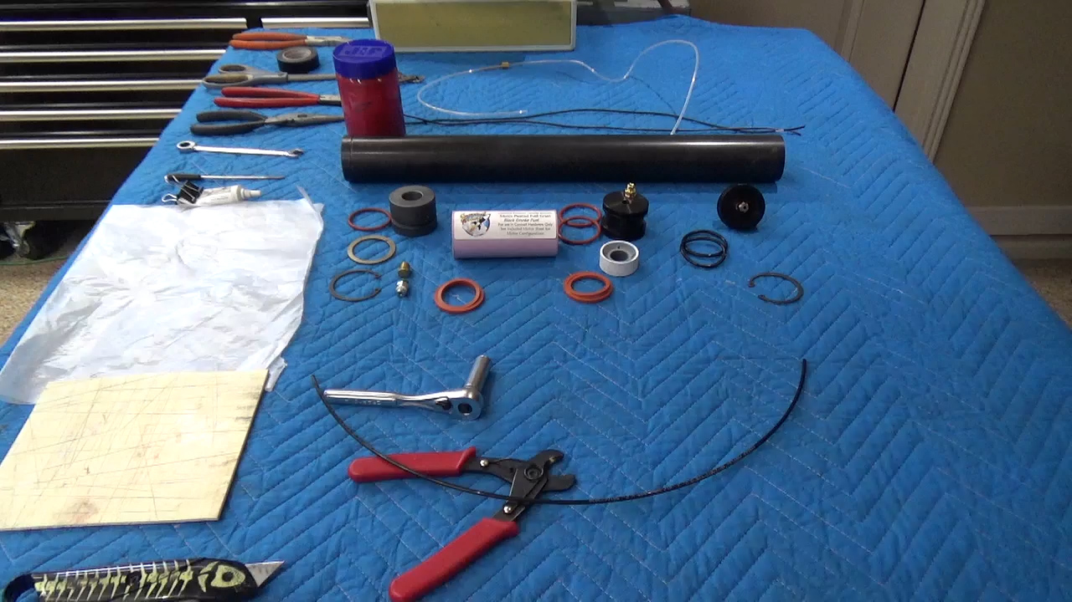
Step 2: Begin by installing Red High Temperature O-Rings onto Nozzle and the CNVA Injector Baffle. Install the Black Buna O-rings on the top Bulkhead. All O-rings are Dash Number 223. O-Rings should be free from any cracks, burns or damage.
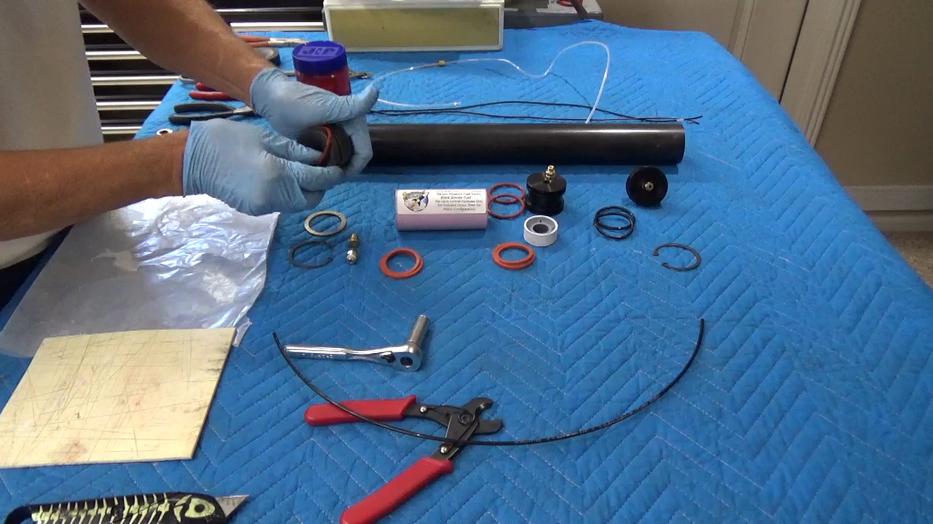

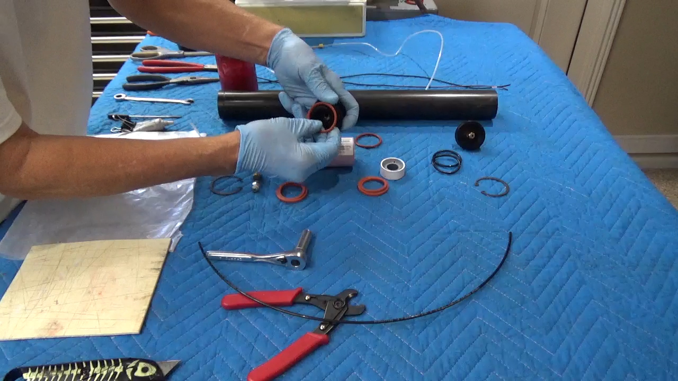
Step 3: Install the CNVA fitting in the CNVA injector baffle. Refer to the attached chart to see how the Injector size, Nozzle size and CNVA are matched for motor performance. Incorrect matching of the three components could lead to anything from substandard performance to a motor CATO. The CNVA is tightened finger tight and given a 1/4 turn only. No sealant is used on the 1/8 NPT pipe threads of the CNVA.
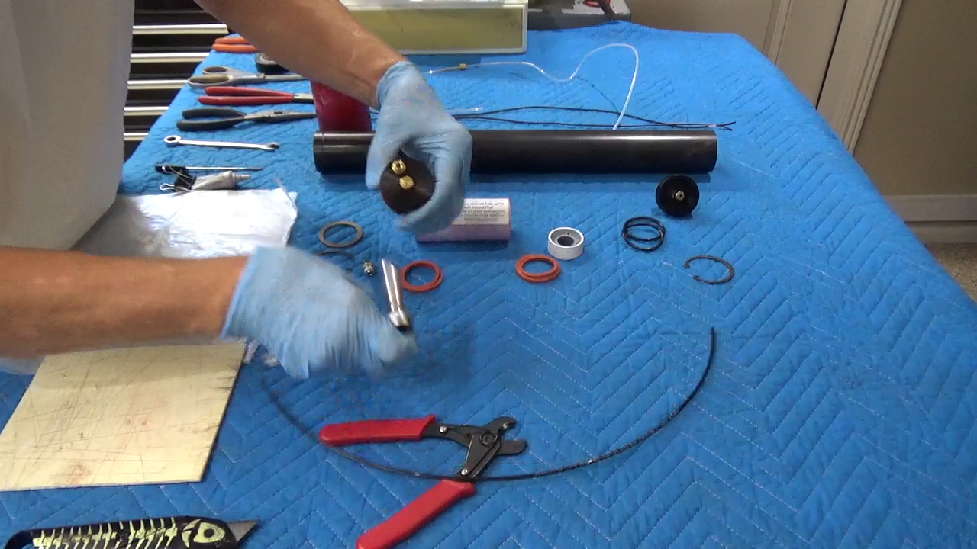
Step 4: Prior to installing the black fill line in the PTC fitting it needs to be squared with a razor knife. Motor performance is impacted if Coax cutters are used on the internal fill line as they crimp the line reducing the internal diameter.
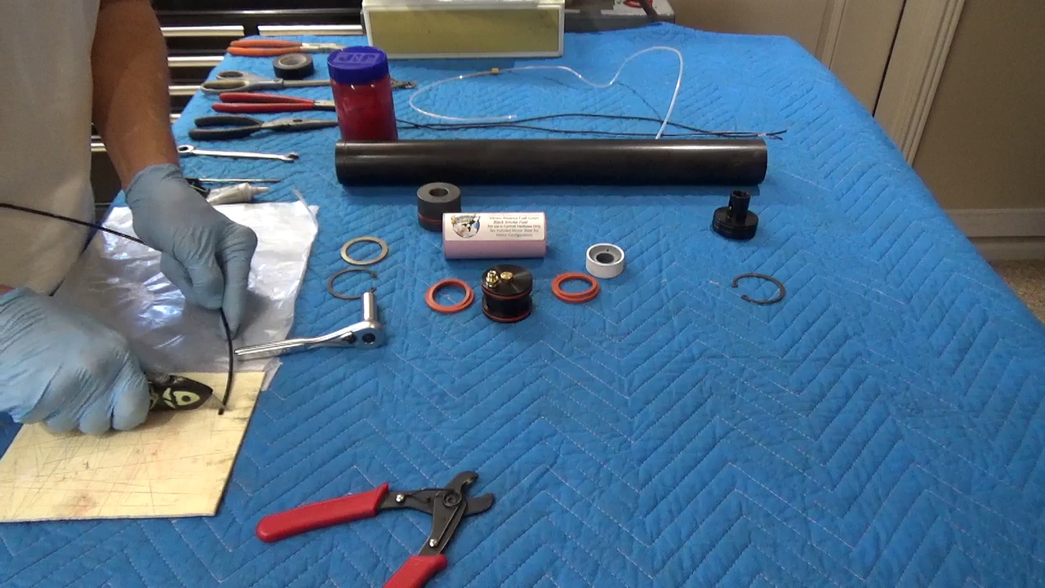
Step 5: Selecting the correct matched PTC fitting that is used as the injector for the motor is critical. The PTC fitting is threaded in finger tight and then given a 1/4 turn to snug the fitting into the cup of the CNVA injector baffle. Once installed insert the trimmed fill line into the PTC. Ensure that the line is fully seated. Once seated pull on the fill line to ensure that it is not possible to pull out of the PTC.
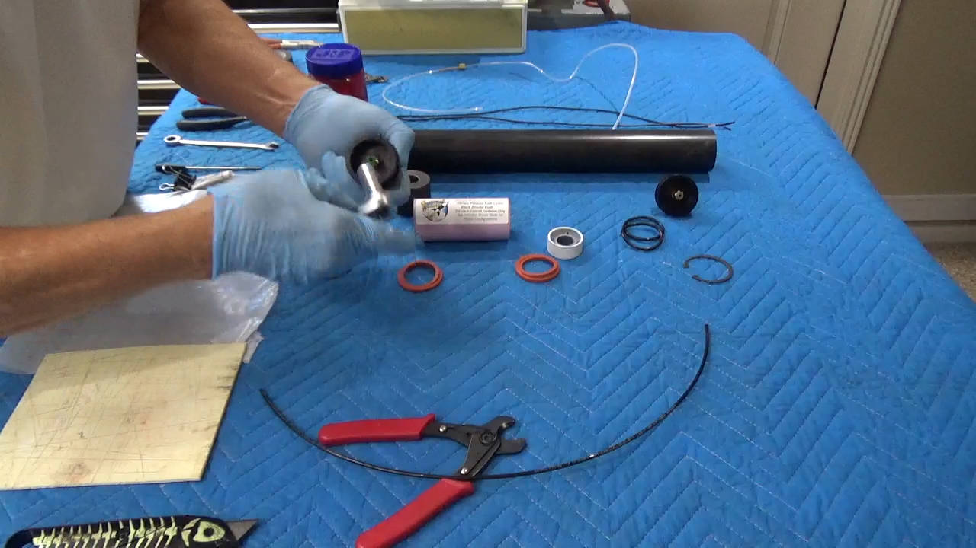
Step 6: Now it is time to install the clear internal vent line. It is supplied with a brass line visible inside of the nylon tube as well as a furel pre-compressed on the outside of the clear vent line. The line also has a coil on the Nitrous Oxide tank side of the line. The straight line which has the most brass tube from the furel is installed into the brass compression fitting on the top side of the CNVA injector baffle. The compression nut supplied with the motor needs to be slid down the clear coiled line so that the compression nut can be tightened finger tight. At that point using a 3/8 box wench or small adjustable wrench tighten the nut an additional 1/4 turn. Since the furel has been pre-compressed additional tightening is not required.
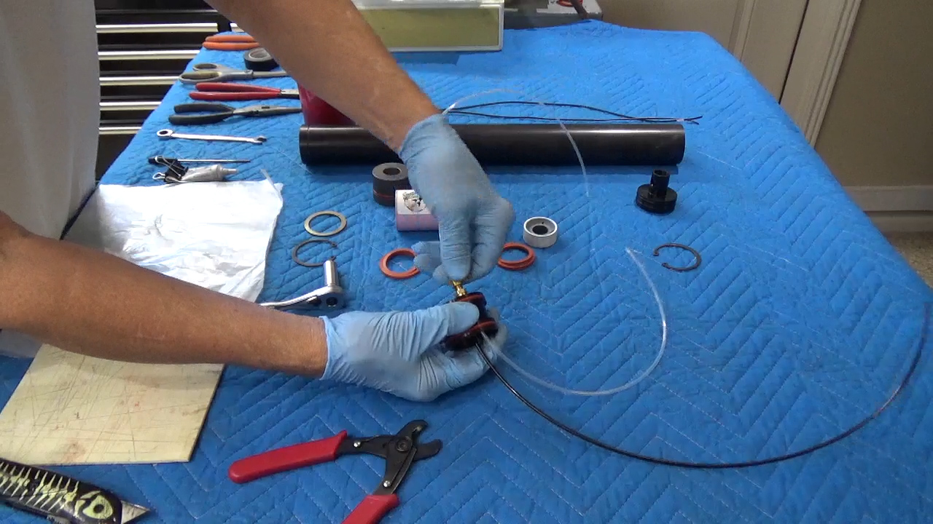
Step 7: Install the igniter cup into the cup of the CNVA injector baffle. The central hole is where the black fill line is inserted so that the flat surface will mate with the inside of the cup. The “Ring of Fire” is pre-drilled with three holes 1/8 inch holes. The central hole goes through the igniter composition to the backside of the cup. The clear vent line needs to be fed thru the backside/flat side of the igniter cup at which time the injector cup is seated in the CNVA injector baffle.
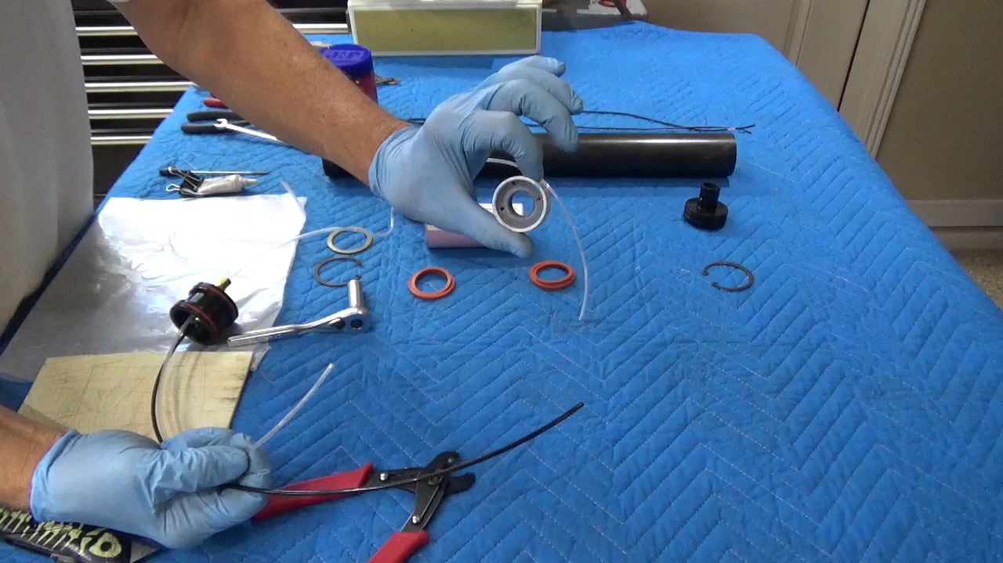
Step 8: Use Krytox™ GPL206 grease on the CNVA injector baffle Red O-rings. apply Krytox™ over the entire O-ring surface area on both O-rings. This allows for an easy fit into the motor case. Several sources for Krytox GPL206 grease are from Contrail Rockets or McMasterCarr. Once greased slide the injector baffle into the bottom of the motor tube. The bottom of the motor tube has the external groove for the thrust washer.
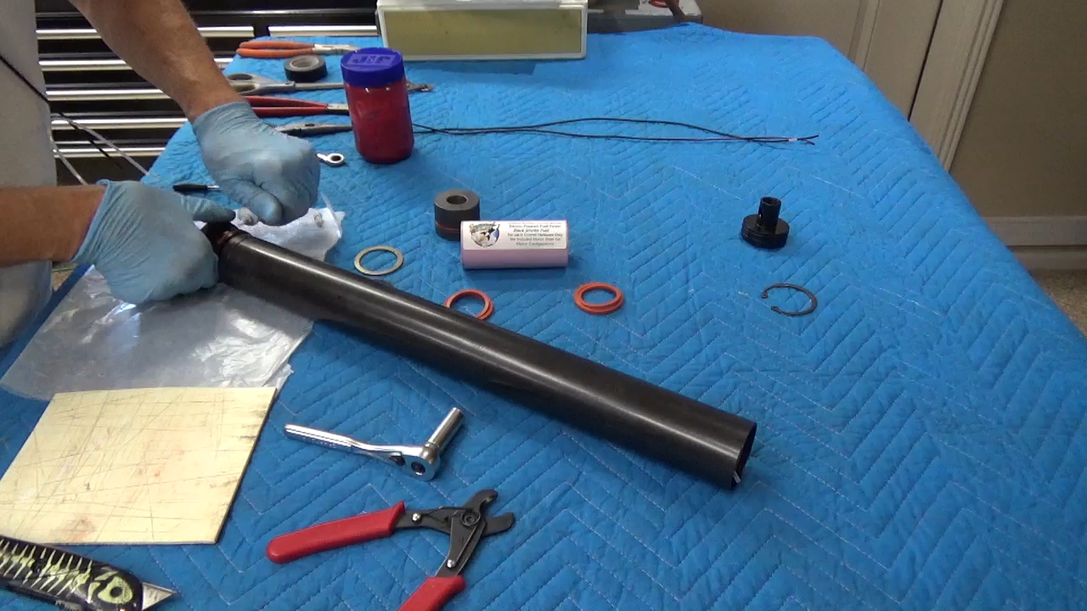
Step 9: Install the twin resistor igniters in the two holes pre-drilled in the “Ring of Fire” igniter cup. Before inserting the igniters, it is necessary to fold over the twisted copper wire that extends past the end of the resistor. If the wire extends to the point that contact could be made to the wires at the other end of the resistor part of the folded wires need to be trimmed off. This folded wire acts as a barb helping to hold the resistor in the ignition composition.

“Ring of Fire” is made from Flammable Material:
Ignition cup filled with a flammable composition handle with caution like done with Pyrodex Pellets. Resistor igniters reduce the risks of static ignition.
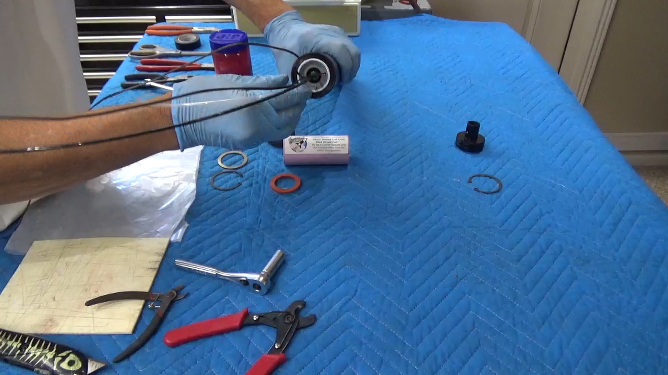
Step 10: It is required to install several wraps of electrical tape on the fill line, vent line and two igniter leads about an inch below the green ring of the PTC injector. The wires should be pushed up towards the injector before taping in an effort to ensure that they are not dislodged during motor assembly.
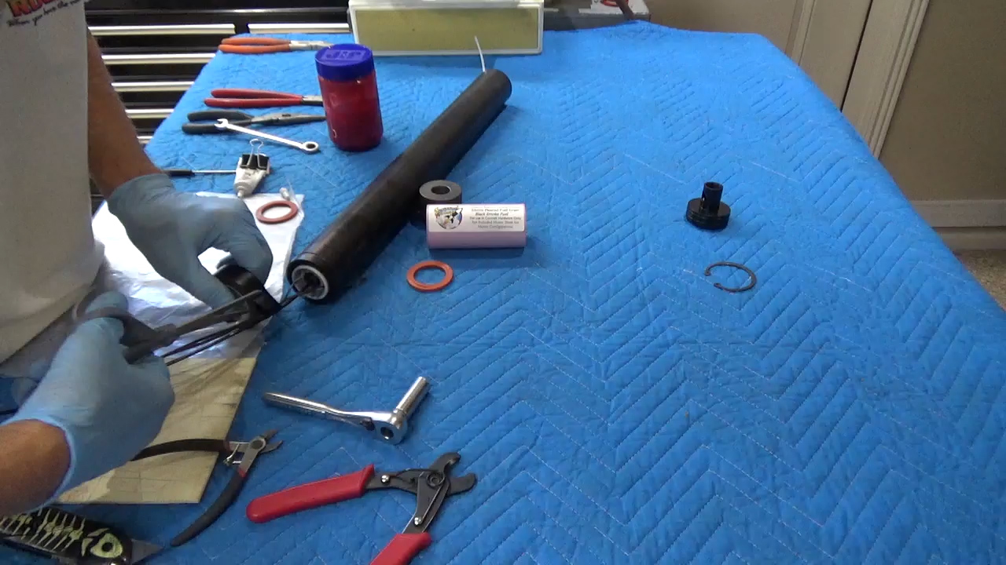
Step 11: A second piece of electrical tape should be used several inches above the end of the clear vent line this holds the lines and wires together making it easier to slide on the other parts. This also ensures that the igniter wires are not pulled from
the “Ring of Fire igniter. 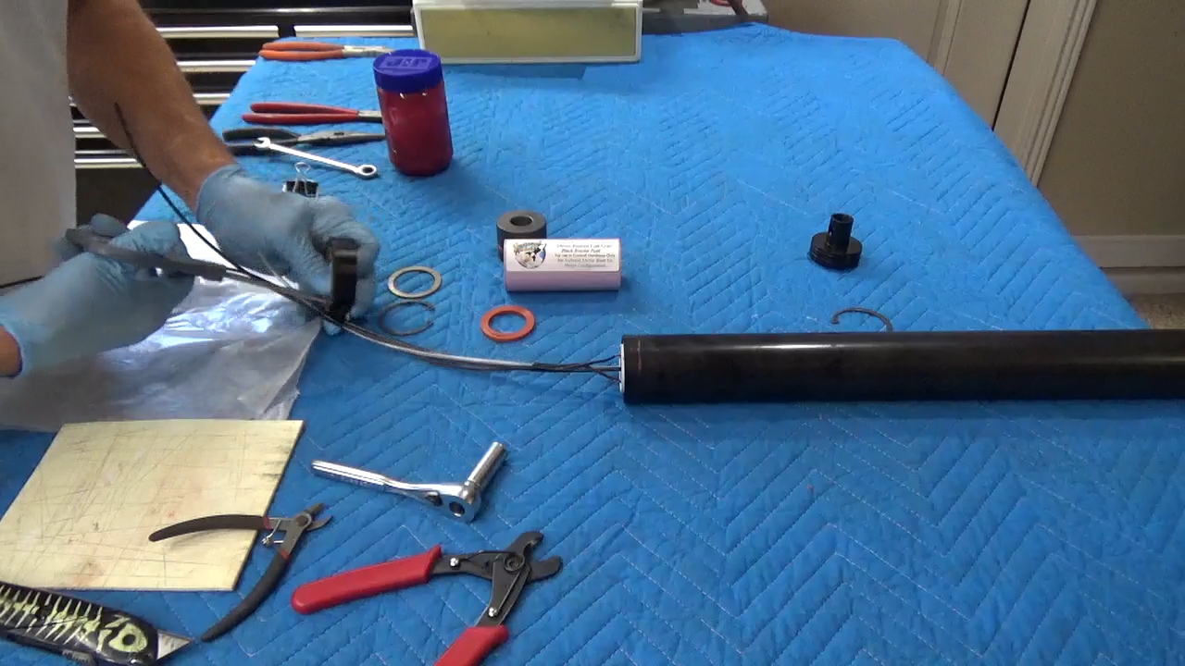
Step 12: It is now time to install a large and small Red Square High Temperature O-ring on the lines exiting the bottom of the motor. These are inserted one in the other to create a flame barrier.
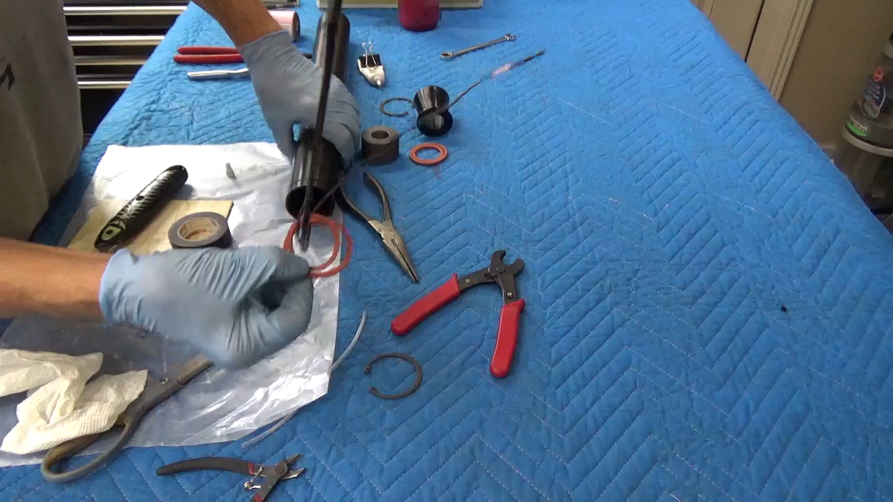
Step 13: You can use the fuel grain to push the CNVA injector baffle and pair of Red O-rings into the motor past the snap ring groove this make inserting the greased grain easier. Using Mobile One synthetic grease or similar, grease the outside of the fuel grain which you have inserted over the wires and nylon lines exiting the motor. As you insert the grain into the motor tube continue to grease the grain. Grease acts as an insulator to the outer case, prevents the flow of gas or liquid down the outside of the grain which could lead to burning on the liner and also make the removal of internal parts easier.
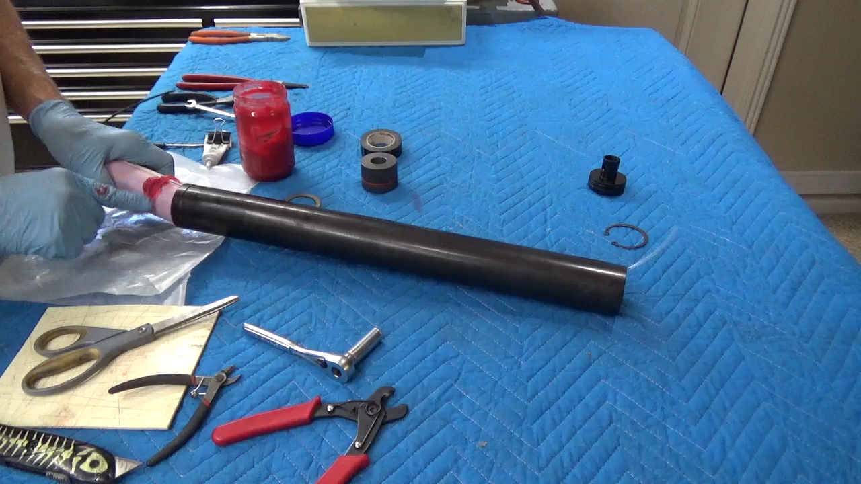
Step 14: Install the second set of large and small Red installing the graphite nozzle easier. Square O-rings on the fill lines. Pushing them into the motor tube past the
snap ring groove which makes it easier to install. 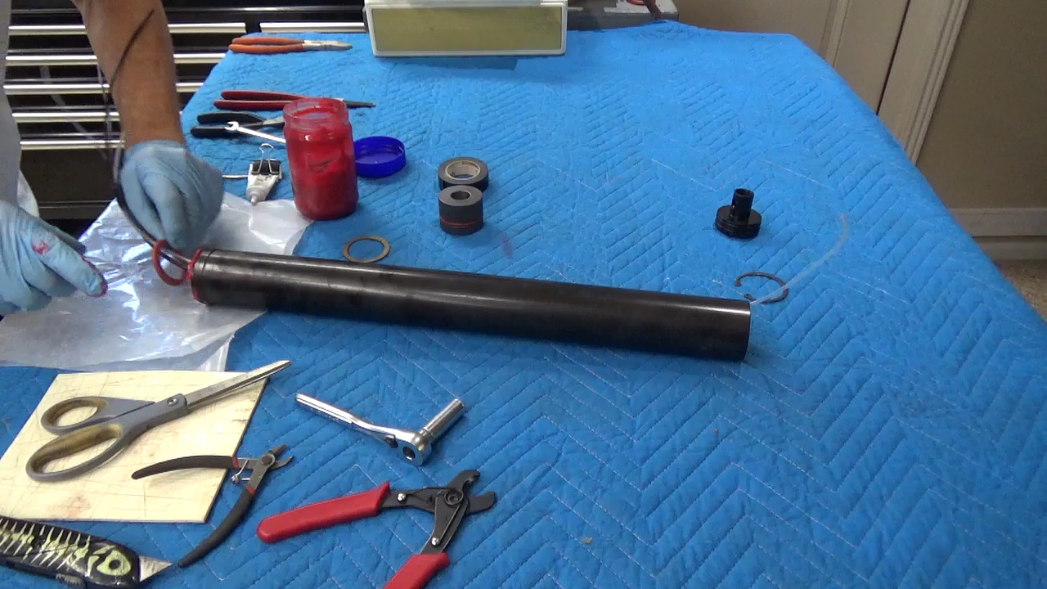
Step 15: Slide the graphite nozzle over the lines and wires. Ensure that you have the convergent installed first. This can also be identified as the O-ring closest to the end of the nozzle. The divergent section of the nozzle is a shallow angle in comparison to the convergent section. Give the Red O-ring and give a light coat of synthetic grease. Slide the graphite nozzle into the motor case.
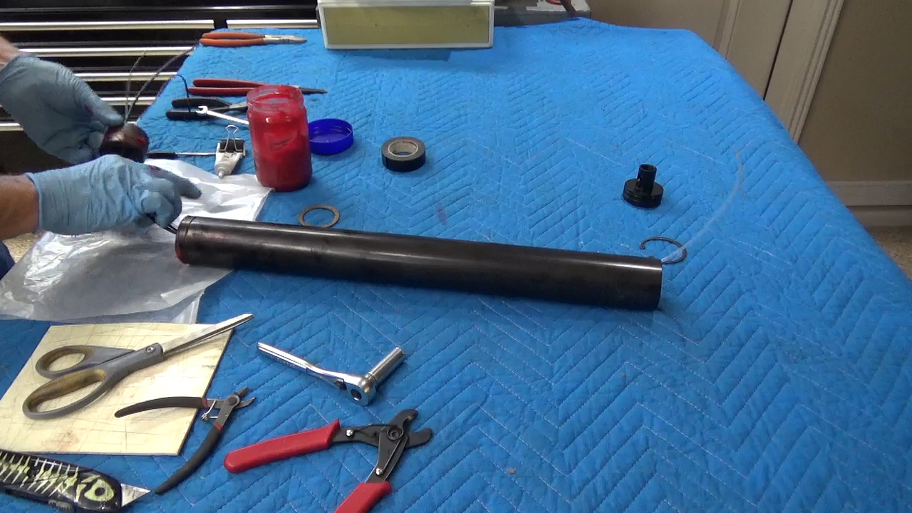
Step 16: Install either the steel nozzle washer or the aluminum divergent over the lines exiting the motor. Ensure that the snap ring groove is visible by pushing the thrust washer/divergent into the motor tube. Now put the snap ring on the lines, utilize safety equipment, it is best to have the snap ring opening to the top so if the snap ring comes out of the plyers it is stopped from flying off to create injury.
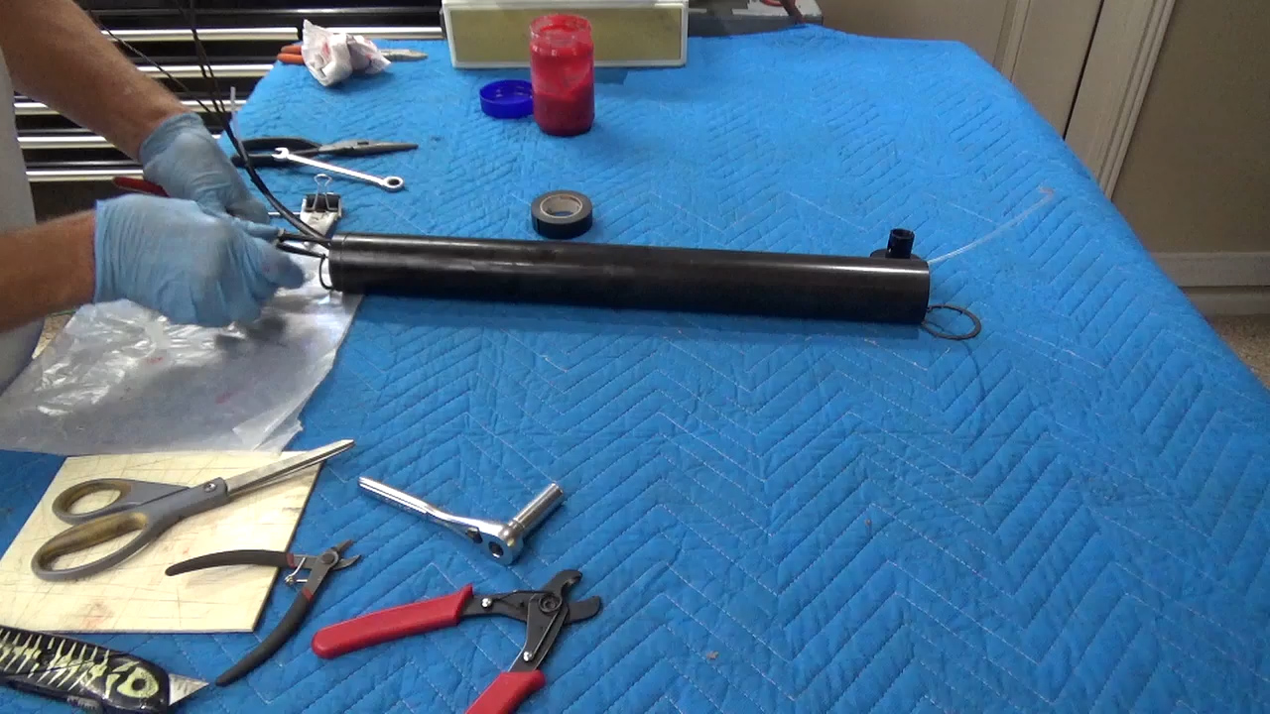Step 17: It is time to trim the internal vent line. Pull on the coiled clear nylon line that exits the top of the motor. It should respond like a nylon spring. Pull slightly out of the motor and trim line using coax cutters. The goal is that once cut it is flush with the end of the motor tube. Pulling to much and cutting could allow the line to recoil into the motor tube out of reach.
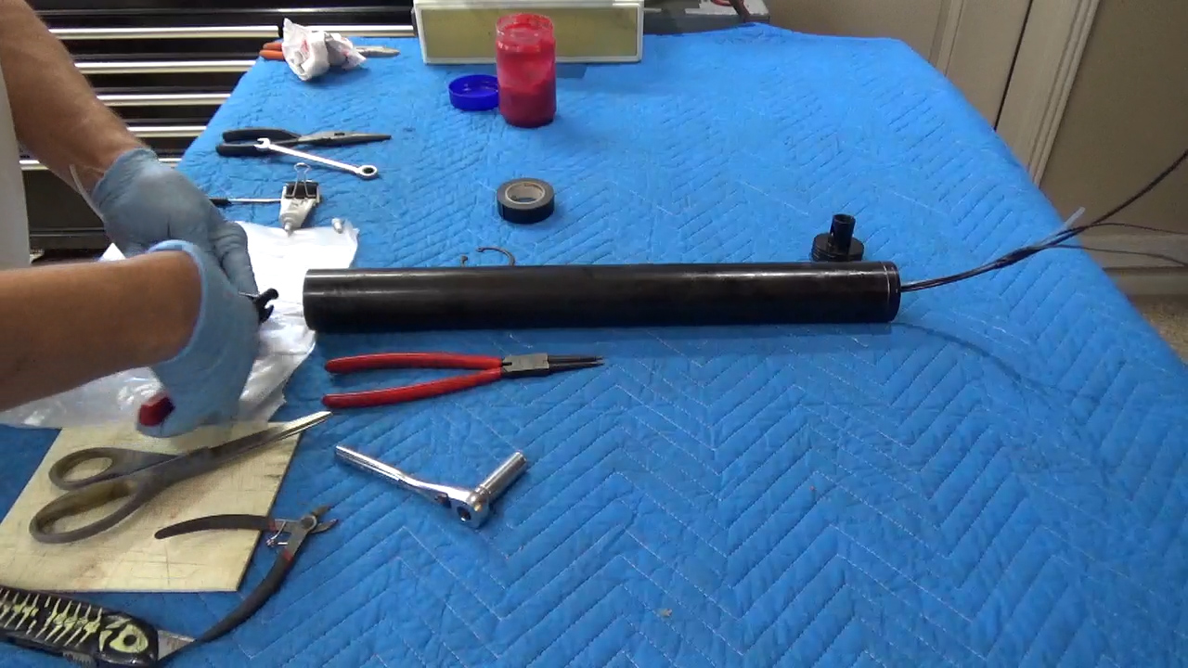

Step 18: Then using needle nose plyers hold the internal vent line while inserting the clear line into the top bulkhead PTC vent fitting. This silver PTC Fitting is reusable flight after flight. Be sure that you feel the line insert past an O-Ring seal and seat snugly onto the bottom of the fitting. Once seated give a slight pull to ensure the line is locked into , and the fitting. Use Krytox™ grease on top bulkhead O-rings.
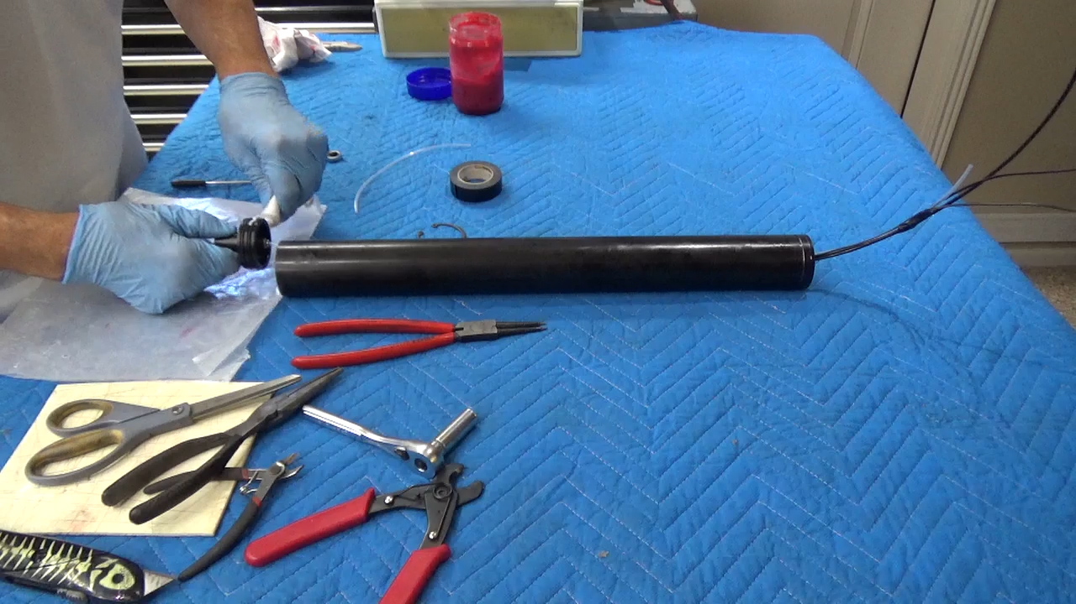
Step 19: Once you have slid the top bulkhead into place ensuring that the snap ring groove is visible. Time to install the snap ring. Again, with Safety glasses or goggles and the snap ring near the motor tube apply pressure to the plyers to compress the snap ring to allow it to fit inside the motor tube and seat into the groove, slight pressure on the plyers will allow you to move the snap ring without removing from the groove to ensure it is correctly seated into the groove.
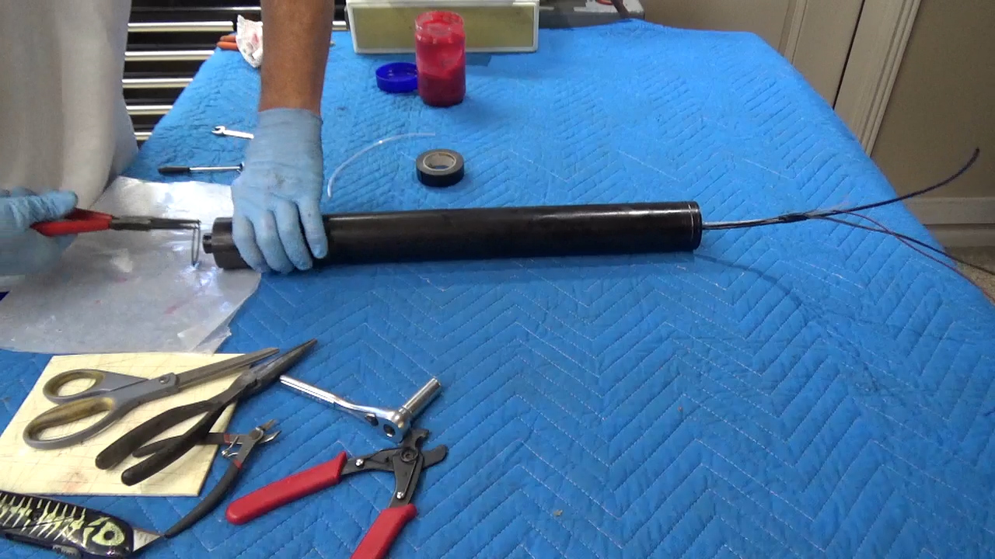
Step 12: Confirm that both snap rings are in place and wipe away any excess grease from the outside of the case. You can expose the wires of the igniters and with one wire from each lead twist them together, do the same with the remaining two wires. Since the resistors are not sensitive to static discharge your motor will not ignite until it receives 12 volts of power from a fire circuit. This eliminates the need to install igniters at the pad. In addition since the motor has yet to be pad filled with Nitrous Oxide it is safe to transport from your assembly area to the RSO and ultimately to the launch pad with the resistor igniters installed.
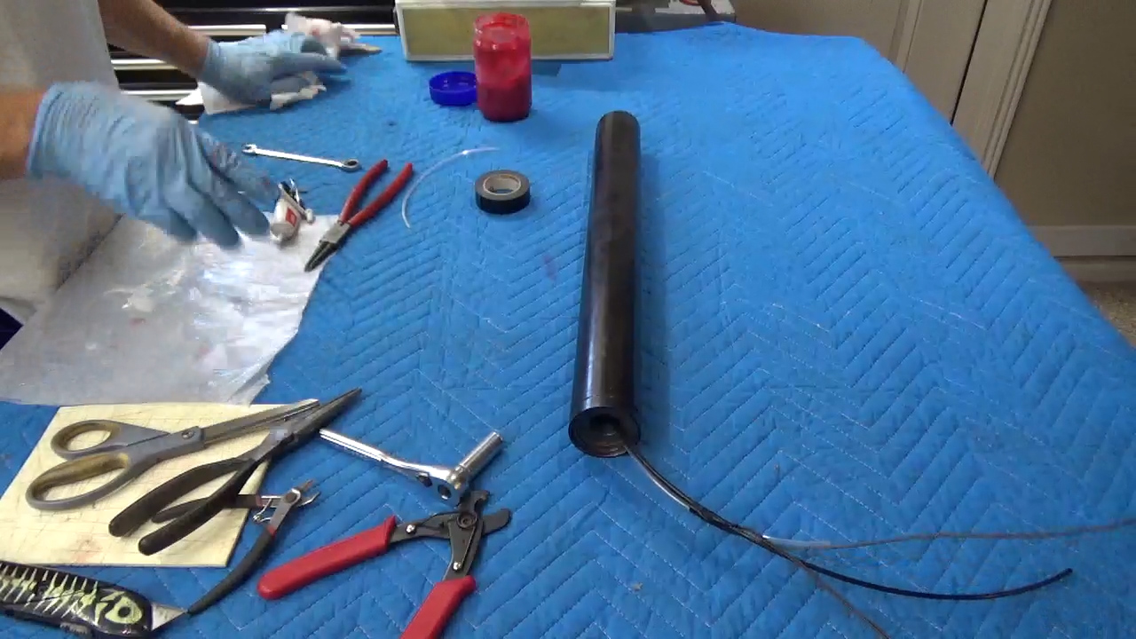
You’re Now Done Assembling your Contrail Rockets Hybrid Rocket Motor.

Safety and First Aid
Contrail Rockets Hybrid Motor Reloads will not burn without the presence of a High Temp Heat Source, and strong oxidizer. If for some reason, any part of a reload is ingested, induce vomiting and seek medical attention. Understand that Nitrous Oxide is a Cryogenic liquid stored at high pressures. When released it can reach temperatures as low as -127 degrees Fahrenheit. Safety equipment needs to be used when working around Cryogenic liquids. Leather gloves and safety goggles as well as an understanding of how the Ground Support Equipment operates is critical for your safety as well as the safety of others.

Warnings

- Only Contrail Rockets Certified Reloads are to be used in Contrail Rockets Hardware. The use of any other manufactures reload in Contrail Rockets Hardware will void your warranty and will also render the assembled motor non-certified.
- Never Approach a Hybrid Motor when filling or while the motor has pressurized Nitrous Oxide in it.
- After Firing your motor, it may be hot, and should be handled with care.
- Always Wear Protective Eyewear, Gloves, and Clothing when working with Hybrid Motors, or Ground Support Equipment.
- Always follow the Tripoli Safety Code as well as the NFPA Safety Code for Mid and High Power Rocketry.
- Not heeding these warnings could result in injury/death to yourself or others.

Filling and Venting Instructions

It is recommended that your hybrid motor be filled remotely using electrical actuated solenoid valves. Manufactures of Hybrid Ground Support Equipment will be more than able and willing to help assist you in the pre-flight setup and procedures which go along with their equipment. If you are not familiar with the equipment, ask them prior to use. It is required that the motor be filled with liquid Nitrous Oxide not gaseous Nitrous Oxide so either the cylinder for filling needs a dip tube or would need to be inverted so that liquid is supplied to fill the motor. The pressure of the Nitrous Oxide should be 750 psi. A variation in pressure between 700 and 800 psi are within the manufactures safety standards and provides thrust levels within 5% of optimal thrust as when 750 psi is maintained. This pressure can be obtained in hotter environments by shading the cylinder. In addition, using a white beach towel tied or bungee strapped to the cylinder are effective methods. Using water for evaporation or Ice water for quicker cooling are also effective means of lowering fill cylinder temperature which in turn lowers your Nitrous Oxide fill pressure. Heating the cylinder can be achieved using commercially available NOS bottle heaters if Solar heating is insufficient. Never use fire or gas heaters to heat the cylinder. While hybrid motors have been launched outside of those recommended pressures be aware that hybrid motors should never be fired when the motor is not venting liquid indicating that the motor is filled with liquid Nitrous Oxide.

Warning at elevated temperatures above 97 degrees or 1069 psi Nitrous Oxide in the fill cylinder are classified as a supercritical fluid and filling or launching a hybrid motor would lead to a CATO.

This hybrid motor is designed with an internal vent which exits the combustion chamber through the nozzle along with the igniter leads and the fill line. The clear vent hose needs to be located in a way that the exiting gas and then liquid is visible from the ROS/LSO area. Having a black background behind the vent hose improves viability.

Launch Setup and Procedure

- In order to fire any Contrail Rockets Hybrid Motor you will need to have available a Hybrid Ground Support Equipment. We recommend the Contrail Rockets Ground Support Equipment, or the Wilson FX Hybrid Ground Support Equipment. For More information on Ground Support Equipment contact a member in your club flying hybrids or Contrail Rockets.
- No Hybrid Motor should be operated when Nitrous Oxide Pressures are less than 650 psi or more than 850 psi. See Attached chart on how Density or combustion pressure are affected.
- It is required that you fill your Hybrid Motor from a Distance of no less than 100 Feet.
- Manufactures of Hybrid Ground Support Equipment will be more able and willing to help assist you in the preflight setup and procedures which go along with there equipment. If you are not familiar with there equipment, ask them prior to use.

Disposal and Cleanup
If for any reason you need to return or dispose of your reload, please contact Contrail Rockets LLC. for information on how to return the item. Appropriate shipping and handling, as well as packaging requirements may be necessary. Any used items should be disposed of in the proper trash receptacle.
Disassembly and Motor Cleaning
Necessary Items:
The tools used for assembly plus the additional items listed below.
Broom Stick or PVC pipe for removing Internals (at least the length of the motor case)
Soap and Water for Cleanup
Paper Towels
Charcoal Lighter Fluid for Cleaning Nozzles
Plyers or Vice Grips to pull out Top Bulkhead

Once you have fired the motor and it is time for cleanup you should begin by removing both snap rings and Nozzle Washer. Then find your pliers or Vice Grips to pull out the top bulkhead cut the clear nylon line with several inches of tube on the bulkhead silver PTC fitting. Push everything out of bottom of the motor by pushing your broom stick or PVC pipe from the top of the motor to the injector baffle through the now empty NOS tank. Use caution not to drop or damage the parts as they exit the bottom of the motor. All reusable parts will need to be cleaned using liquid soap and water or charcoal lighter fluid for the graphite nozzle. O-rings should be checked for cracks or burns, replaced as necessary. Note the large square O-rings can be re-used four times but the smaller Square O-rings need to be replaced after each flight. Additional small Red Square O-rings come with each new reloads.

Disclaimer
Contrail Rockets LLC. specifically disclaims any warranties with respect to any and all products sold or distributed by it, the safety or suitability thereof, or the result obtained, whether express or implied, including without limitation, any implied warranty of merchantability of fitness for a particular purpose and/or any other warranty. Buyers and users assume all risk, responsibility and liability whatsoever for any and all injuries (including death, losses, or damages to persons or property), including consequential damages arising from the use of any product or data, whether or not occasioned by seller’s negligence or based on strict product liability or principles of indemnity or contribution. Contrail Rockets Neither assumes nor authorizes any person to assume for it any liability in connection with the use of any product or data.

Contrail Rockets LLC. Ensures that reasonable care during the design and manufacture process. Because we can not control the use or storage of our products, Contrail Rockets, can not be held responsible for any personal injury or property damage resulting from the handling, use or storage of its products. The Purchaser assumes and accepts all liabilities and risks associated by the handling or use of Contrail Rockets Products. By Purchasing a Contrail Rocket, LLC. product, you are hereby acknowledging the above disclaimer, and agreeing to not hold Contrail Rockets, LLC., its owners, employees, stockholders, partners, or subcontractors for any harm or blame caused by the use of our product, caused by the purchaser, and/or end user.

Warranty
Our Products are Warranted for a time period of one year, from the date of original purchase. The warranty expressed by Contrail Rockets LLC., covers defects in material or workmanship. There shall be no expressed or implied warranty, which covers any item damaged, through the use of a Contrail Rocket Motor. This includes the motor hardware, electronics, and any other items which suffer from the misuse, neglect caused by the user. Contrail Rockets LLC. Reserves the right to alter the Warranty at any time, at their discretion.
Contact Information
Contrail Rockets LLC.
1894 E. Tradition Ln.
Lake Havasu City, AZ 86404
United States of America

Phone Number: 928-208-5580
Website: http://www.contrailrockets.com
Manufacture Date:

Contrail Nickel Vortex Adapter |  |  | 54 mm
Speed | Injector | Vortex adapter | Throat ID
X-Slow | 1/8" | # - 1 - 1/8 NPT | 0.3125
Slow | 1/8" | # - 2 - 1/8 NPT | 0.3125
Medium | 3/16" | # - 2 - 1/8 NPT | 0.3750
Fast | 1/4" | # - 3 - 1/8 NPT | 0.5000
X-Fast | 5/16" | # - 4 - 1/8 NPT | 0.6250

Thermodynamic Properties of Nitrous Oxide
Temperature | Pressure p.s.i.a | Density Liquid lb/cu/ft | Specific Volume Vapor cu ft/lb | Enthalpy Liquid BTU/lb | Enthalpy Vapor BTU/lb
-127 | 14.7 | 80.0 | 5.5 | -98.5 | 63.8
32 | 460.0 | 57.0 | 0.1785 | -33.3 | 73.5
40 | 520.0 | 54.7 | 0.16 | -28.2 | 73.3
50 | 590.0 | 52.3 | 0.138 | -21.2 | 72.6
60 | 675.0 | 49.2 | 0.119 | -14.2 | 72.0
70 | 760.0 | 46.5 | 0.106 | -7.0 | 70.7
80 | 865.0 | 40.0 | 0.08 | 0.0 | 69.0
97 | 1069.0 | 26.5 | 0.0377 | 66.5 | 66.5

